Design Plan: | Document Name: E R Diagram | SWD/Form No.6A
Effective Date: | Version: 1 | Page No

5.E R Diagram.

Bill_Rooms
BillFoods

Has
1
1
Has
N
1
N
1
1
Book
Book
Customer
Booking_Rooms
Booking_Buffet

1
N
Has
Has
1
1

Booking_Details
Buffet

N
1
Has
Has
1
1

Room
BuffetDetails

1
1
Has
Has
1
1

Room_Type
Foods

Customer_ID
Customer_Name
Customer_Passpor
Customer_Address
Customer

Customer_Phone
Date_of_Birth

Customer_Gender

Booking_ID
Booking_ID

Checkin_Date

Customer_ID
Booking_Rooms
Booking_Details
Checkout_Date

Customer_ID
Room_ID

Room_ID
Room_Type
Room_ID
Name_Room
Room_Type_Name
Description
Price
Room_Type

Room_Type
Room

Room_Status

Bill_ID

Room_ID
Room_Type
Total_Pay
BB_ID
Bill_Room

Booking_ID
Bill_Date
BB_Date
Customer_ID
Booking_Buffet

Price
Checkout_Date

Checkin_Date

UserName
Password
FullName
Address
Phone
Login

Permission

Buffet_ID

BB_ID
Buffet_ID
Type_Buffet
BuffetDetails

Price
Buffet
Payment
Food_ID

Status
Quantity
BillBuffet_ID
BB_ID
Food_ID
Name_Food
Bill_Date
BillFoods
Price
Type_Food
Total_Pay
Foods
Customer_ID
Kind_Food
Country_Food

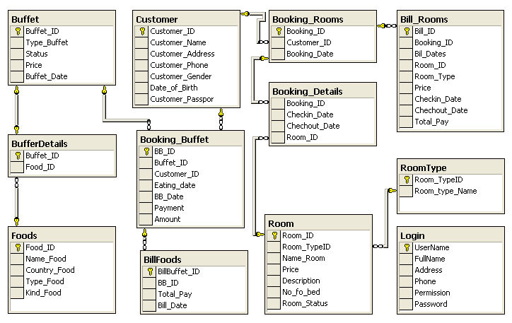
 | Prepared By (Student) | Approved By (Teacher)
Date: 25/09/2008 | Khai | Tran Thi Hong An

